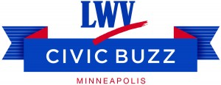
Broken:
My Story of Addiction and Redemption
Tuesday, March 7, 2017
Black Forest Inn, 26th and Nicollet Ave S
5:30 Networking
6:15-7:30 Speaker & Discussion
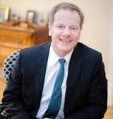William C Moyers will share his spiral into the grip of addiction, his struggles to overcome the illness and his two decades of advocacy work on behalf of Hazelden Betty Ford Foundation
Mr Moyers is the vice president of public affairs and community relations for the Hazelden Betty Ford Foundation, based here in Minnesota. As the organization’s public advocate since 1996 Moyers carries the messages about addiction treatment and recover to audiences across the nation.
The Civic Buzz meets the first Tuesday of each month
5:30 pm Gather and Networking
6:15 pm Speaker
6:30-7:30 pm Questions and Discussion
Black Forest Inn Banquet Room
Nicollet Avenue South at 26th St. W.
We gather at 5:30 in Black Forest Inn’s banquet room. Order drinks and food. We begin our meeting at 6:15. Each month we have a speaker followed by discussion. Each month will have a new topic/issue for discussion.
Anyone interested in discussing pressing topics related to citizen engagement are invited. Topics studied and discussed in the 2016 were the Voting Rights Act, Amending the U.S. Constitution, and Money in Politics, School Culture, Winning Campaigns, Voter Turnout, Legislating by Amendment, Race, and the state of the Mississippi River.
We would love to have you join us. A discussion with the League of Women Voters means that all voices are heard and we take opinions seriously. In the end, we all learn something new and hopefully have a broader understanding of the issues.
Thank you to our neighborhood sponsor the Whittier Alliance.

