Minneapolis 2040 “Built Form” Map for Bryn Mawr
(Describes what could be built where if the plan is adopted without changes)
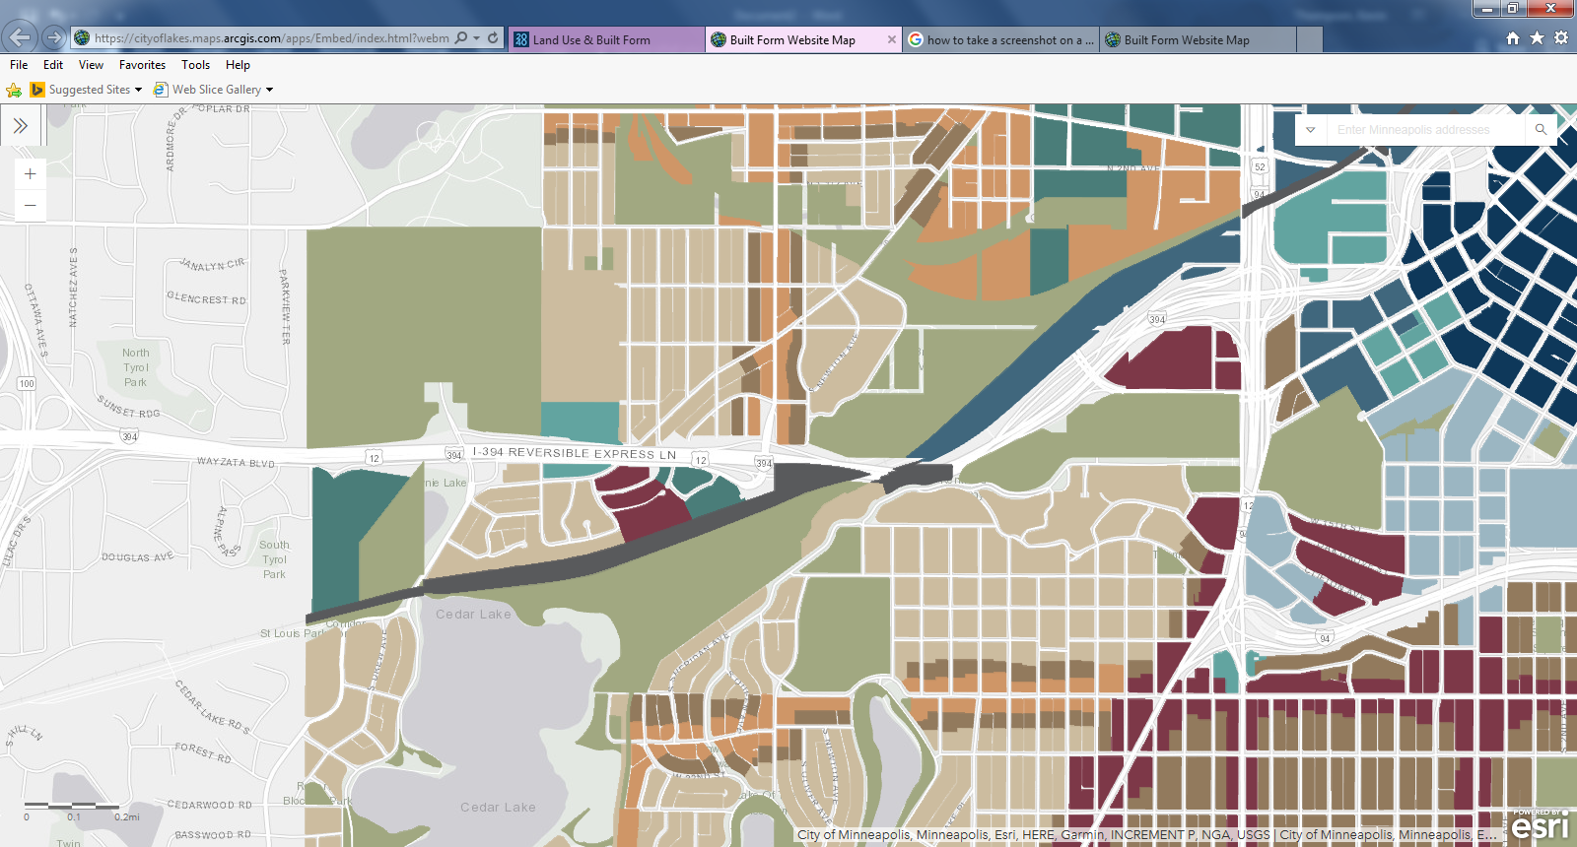
Proposed Built Form:
Interior 2 (Light Brown—Most of Bryn Mawr)
The Interior 2 district is typically applied in parts of the city that developed during the era when streetcars were a primary mode of transportation, in the areas in between transit routes.
Built Form Guidance: New buildings in the Interior 2 district should be small-scale residential structures on traditional size city lots with up to four dwelling units, as well as multifamily buildings on a limited number of combined lots.Building heights should be 1 to 2.5 stories.
Proposed Built Form:
Interior 3 (Dark Brown—1 Block either direction from Penn/Glenwood. West side of Oliver Ave. S., East side of Queen Ave. S., North side any East/West streets south of Glenwood)
The Interior 3 district is typically applied in parts of the city closest to downtown, in the areas in between transit routes. It is also applied adjacent to the Corridor 4 and 6 districts, serving as a transition to lower intensity residential areas.
Built Form Guidance: New development in the Interior 3 district should reflect a variety of building types on traditional size city lots, along with combining of parcels for multifamily buildings.As the lot size increases, allowable building bulk should also increase. Building height should be 1 to 3 stories.
Proposed Built Form:
Corridor 4 (Orangey Brown—Along Penn Ave and Glenwood Ave.)
The Corridor 4 district is typically applied along high frequency transit routes that are on narrower rights of way as well as select streets with local transit service.It is also applied near downtown in areas between transit routes, and serves as a transition between lower intensity residential areas and areas immediately surrounding METRO stations.
Built Form Guidance: New development in the Corridor 4 district should reflect a variety of building types on both small and moderate-sized lots, including on combined lots.The length of buildings along the street should be limited in order to support a comfortable pedestrian environment. As the lot size increases in this district, allowable building bulk should also increase.Building heights should be 1 to 4 stories. Requests to exceed 4 stories will be evaluated on the basis of whether or not a taller building is a reasonable means for further achieving Comprehensive Plan goals.
Proposed Built Form:
Corridor 6 (Purple)
The Corridor 6 district is typically applied along high frequency transit routes as well as in areas near METRO stations.
Built Form Guidance: New development in the Corridor 6 district should reflect a variety of building types on both moderate and large sized lots. As the lot size increases in this district, allowable building bulk should also increase.The length of buildings along the street should be limited in order to support a comfortable pedestrian environment. Building heights should be 2 to 6 stories.Building heights should be at least 2 stories in order to best take advantage of the access to transit, jobs, and goods and services provided by the Corridor 6 district.Requests to exceed 6 stories will be evaluated on the basis of whether or not a taller building is a reasonable means for further achieving Comprehensive Plan goals.
Proposed Built Form:
Transit 10 (Turquoise)
The Transit 10 district is typically applied along high frequency transit routes, adjacent to METRO stations, in neighborhoods near downtown, and in downtown.
Built Form Guidance: New development in the Transit 10 district should reflect a variety of building types on both moderate and large sized lots. As the lot size increases in this district, allowable building bulk should also increase.The length of buildings along the street should be limited in order to support a comfortable pedestrian environment.Building heights should be 2 to 10 stories. Building heights should be at least 2 stories in order to best take advantage of the access to transit, jobs, and goods and services provided by the Transit 10 district.Requests to exceed 10 stories will be evaluated on the basis of whether or not a taller building is a reasonable means for further achieving Comprehensive Plan goals.

Link to the map:
https://cityoflakes.maps.arcgis.com/apps/Embed/index.html?webmap=d45a1edfef284ffc9d430e31cb914ad4&extent=-93.3267,44.9514,-93.1999,45.0097&zoom=true&scale=true&search=true&searchextent=false&legend=true&disable_scroll=false&theme=light
Ways to Comment:
https://minneapolis2040.com/how-to-comment/

